Project Terrapin’s Turtle Garden Project
What are Turtle Gardens?
- Turtle Gardens are patches of sandy soil above the high water line that provide nesting habitat that is less susceptible to flooding.
Why are Turtle Gardens important?
- Nesting habitat is being lost due to shoreline development, erosion and flooding.
- Turtle Gardens can provide nesting habitat for terrapins that would otherwise cross roadways and put themselves in danger to find suitable habitat to nest.
- Turtle Gardens give terrapins a place to nest without risking their safety.
How are Turtle Gardens made?
- A suitable area for a Turtle Garden is chosen based on terrapin sightings and their access points to land.
- The Turtle Garden is made of a mixture of sands and soils of different particle sizes to best imitate natural conditions of a terrapin nesting habitat.
- The sand is spread around the area above the high water line with at least two feet of elevation to give terrapins plenty of space to dig down without being below the high water line.

Example of the Turtle Garden Process
Turtle Garden at the Long Beach Island Foundation of the Arts and Sciences, 2015
Before After 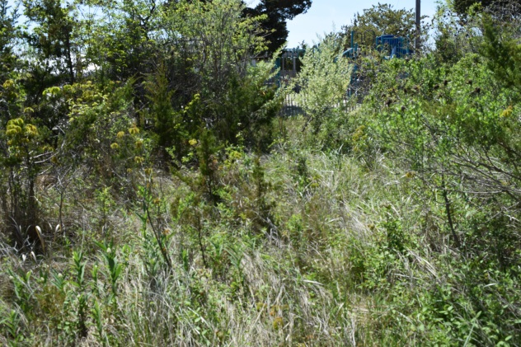 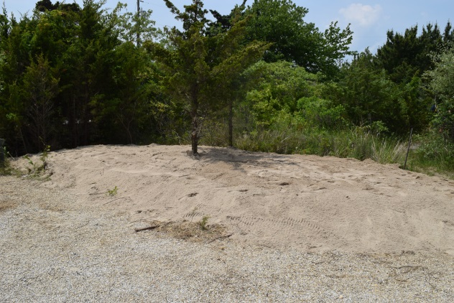
The Problem
Terrapins at the LBI Foundation were nesting in the parking lot where they could be hit by cars.
The Process
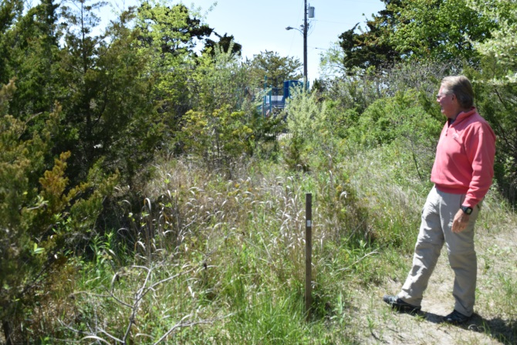 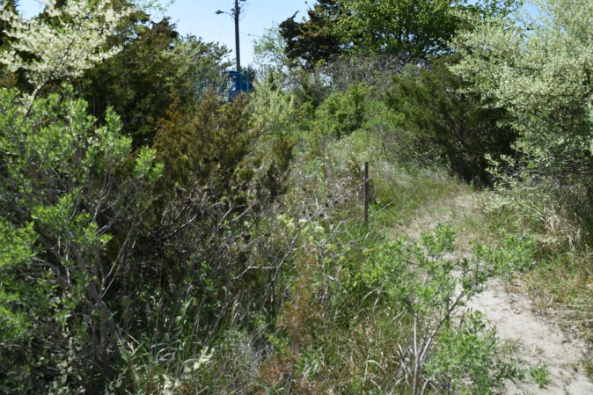
- We first survey the location to decide on the best place to put the Turtle Garden.
- In this case, we decided the best place was next to the path the terrapins take out of the marsh before they get to the parking lot.

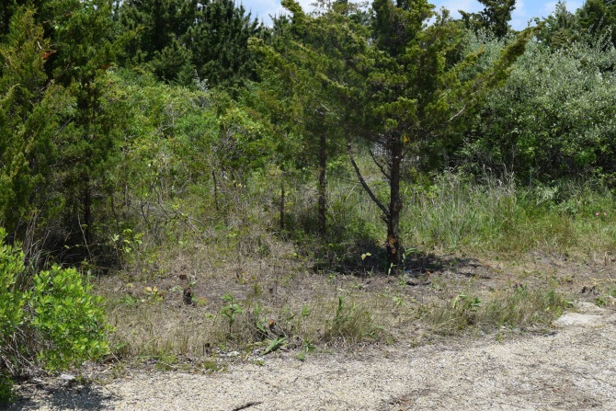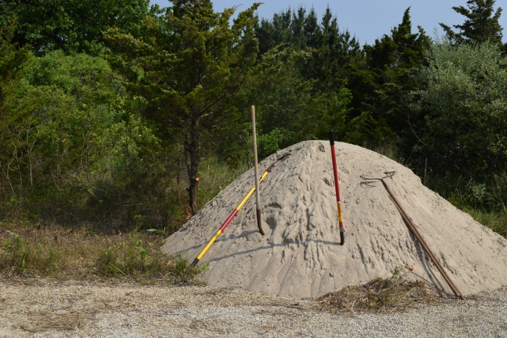
- The area chosen is then cleared of most vegetation, but we leave enough to provide some shade to the Turtle Garden.
- Once the area is cleared, the sand mixture used for the Turtle Gardens is delivered.
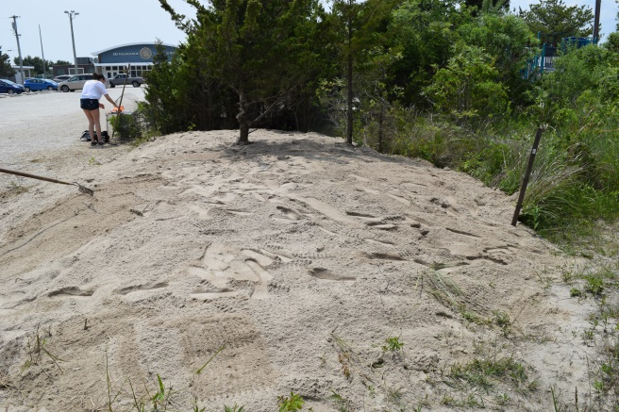
- The sand is then spread throughout the selected area evenly creating a two foot elevation.
- All sides of the Turtle Garden are given a gentle slope to give the terrapins easy access to the site.
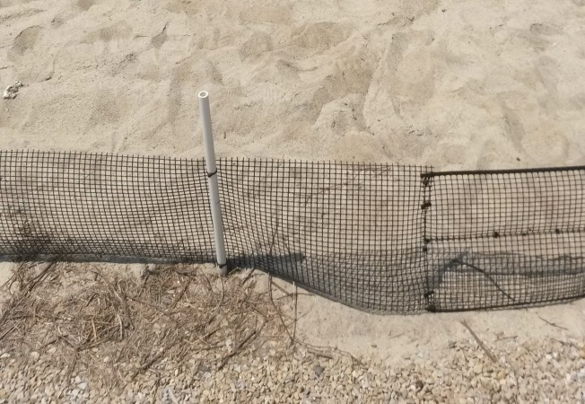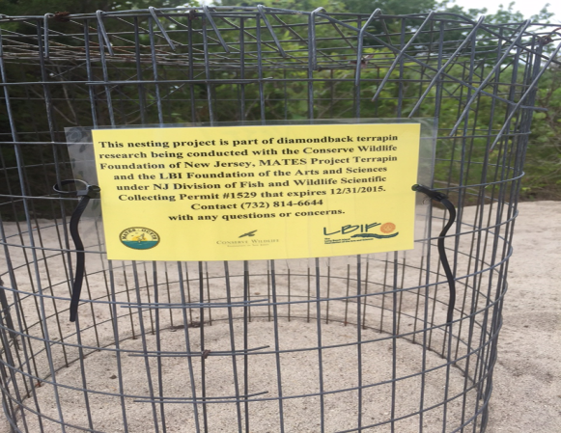
- At this particular Turtle Garden, a small fence was installed around it to keep the terrapin hatchlings from wandering into the parking lot after they emerge.
- This site also used cages over the nests to provide protection from predators while still allowing hatchlings to escape and an opportunity to study them and educate the public about diamondback terrapins.
The Results
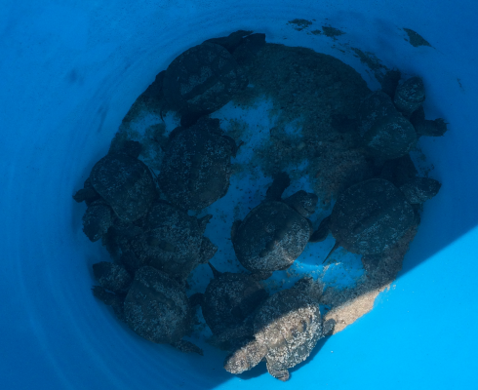
The first year was a success with most of the eggs hatching from five nests in the Turtle Garden!
- All of the eggs hatched in two of the five nests (8 and 10 eggs).
- Two nests hatched all but one of their eggs (10 of 11 eggs and 3 of 4 eggs).
- One nest hatched 3 of 8 eggs.

